Task 3: Backup Configuration for Web Servers
Objective
To configure automated, scheduled, and verified backups for:
Sarah’s Apache server
Mike’s Nginx server
Backups ensure data integrity, disaster recovery, and compliance with operational standards.

Step 1: Create Central Backup Directory
All backups must be stored securely in /backups.
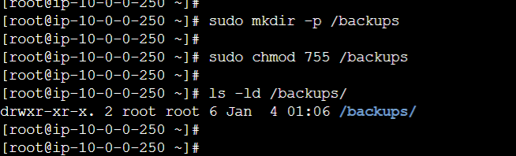

Step 2: Create Backup Script for Apache (Sarah)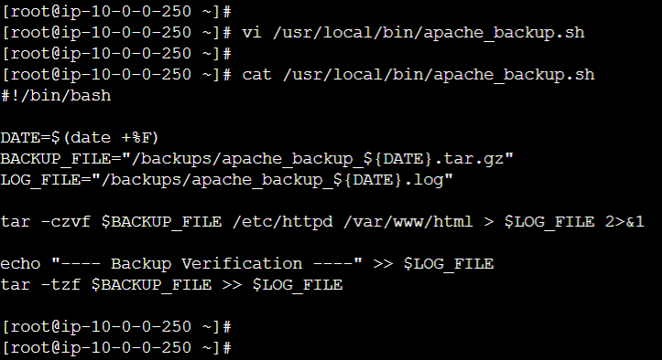

Make script executable:
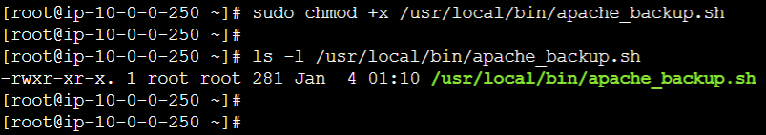

Step 3: Create Backup Script for Nginx (Mike)
File: /usr/local/bin/nginx_backup.sh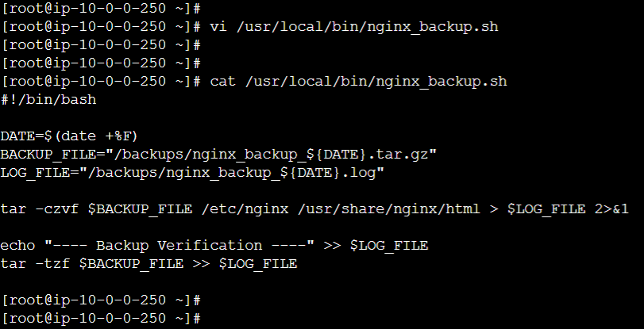

Make script executable:
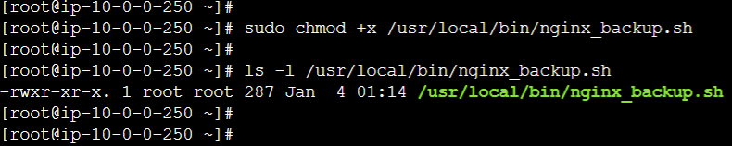

Step 4: Test Backup Scripts Manually
Test Apache & Nginx backup as well as Verify files:
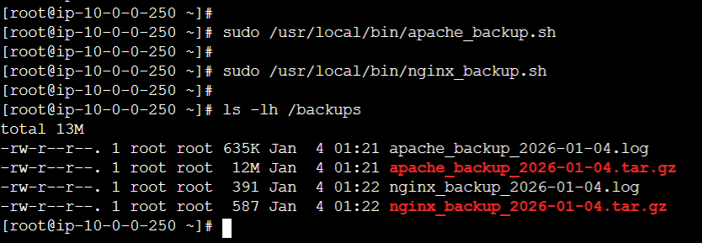

Step 5: Verify Backup Integrity
Apache verification:
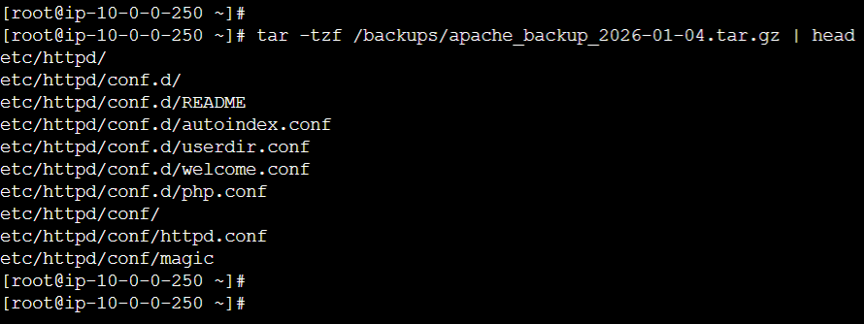

Nginx verification:
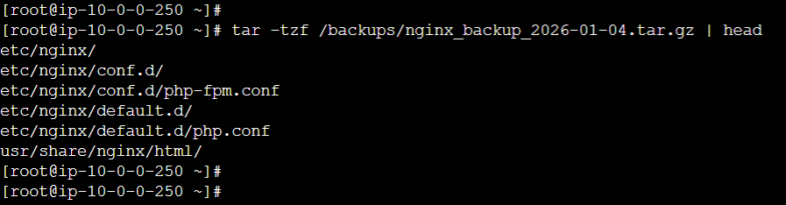
Log file content apache: 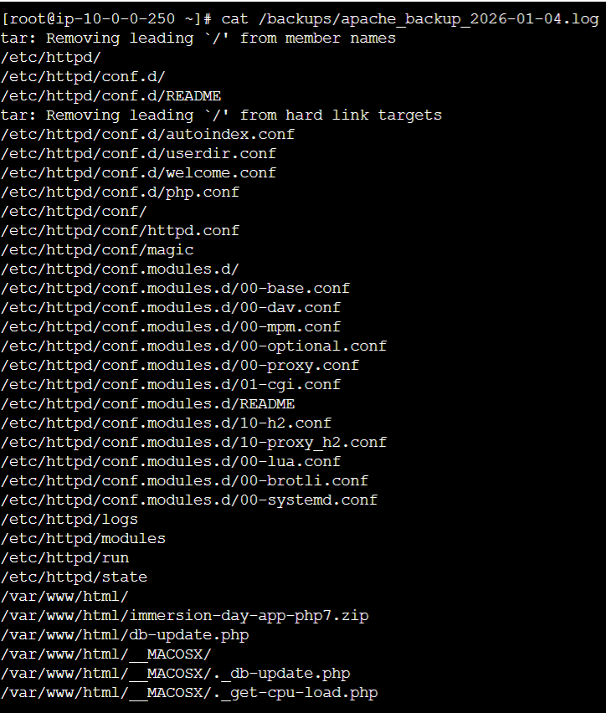

Log file content nginx:
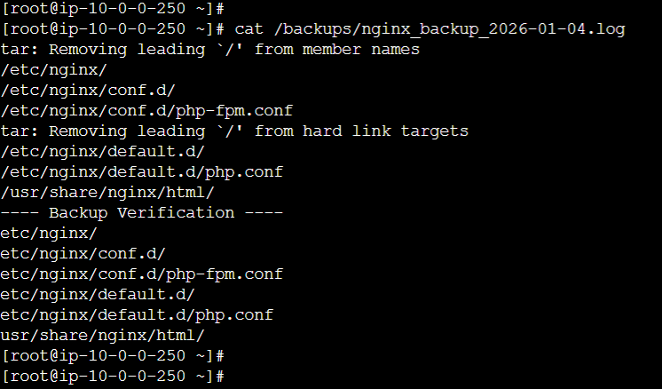

Step 6: Configure Cron Jobs (Every Tuesday at 12:00 AM)
